**Task:7**

Prepare your own use case report for any of the given ICs (FPGA/ASIC/SoC) and its application in a real time application scenario.

**Texas Instruments ASIC: AFE4404**:

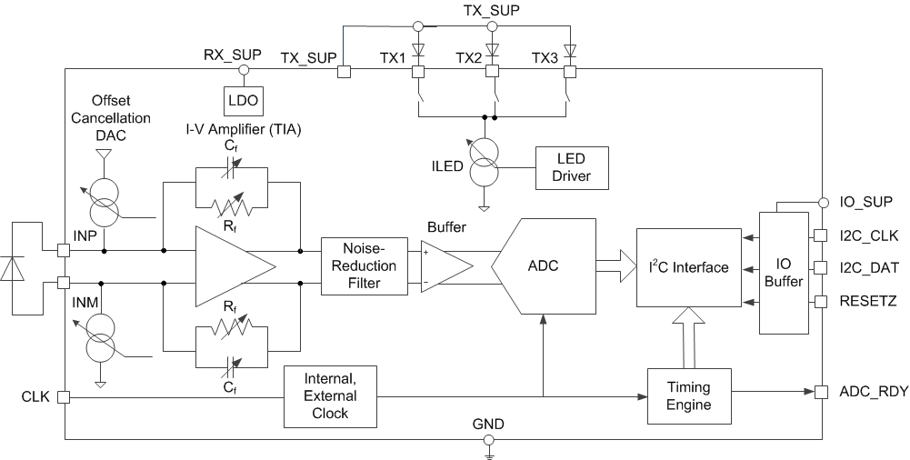

Fig. 1 Architecture of AFE4404

The internal architecture of a pulse oximeter consists of several key components and subsystems that work together to measure and display oxygen saturation and pulse rate. Here’s an overview of the main components and their functions:

**1. Light Emitting Diodes (LEDs)**

* **Red LED**: Emits red light typically around 660 nm wavelength.
* **Infrared LED**: Emits infrared light typically around 940 nm wavelength.
* These LEDs shine light through the tissue (e.g., fingertip) to the photodetector.

**2. Photodetector**

* A sensor that detects the intensity of light that has passed through the tissue.
* Measures the amount of red and infrared light that reaches it.

**3. Analog Front End (AFE)**

* **Amplifiers**: Enhance the small signal received by the photodetector.
* **Filters**: Remove noise from the signal to ensure accurate readings.
* **Analog-to-Digital Converter (ADC)**: Converts the analog signals into digital data for processing.

**4. Microcontroller or Microprocessor**

* Processes the digital signals received from the ADC.
* **Signal Processing Algorithms**: Apply algorithms to calculate SpO2 and pulse rate from the processed data.
* **Calibration**: Uses pre-defined calibration curves to convert the ratio of red to infrared light absorption into oxygen saturation percentage.

**5. Display and User Interface**

* **LCD or LED Display**: Shows the SpO2 and pulse rate readings.
* **Buttons**: Allow the user to operate the device, turn it on/off, and sometimes navigate through settings.

**6. Power Supply**

* Typically powered by batteries (e.g., AA, AAA, or rechargeable batteries).
* **Power Management Circuit**: Ensures stable power supply to all components and manages battery usage.

**7. Communication Interface (Optional)**

* Some advanced models have Bluetooth or USB interfaces for data transfer to external devices like computers or smartphones.

**8. Housing and Clip Mechanism**

* **Clip**: Designed to fit over a fingertip or earlobe.
* **Housing**: Encases all the electronic components and provides a user-friendly interface.

**Signal Processing Steps**

1. **Light Emission**: LEDs emit red and infrared light through the tissue.
2. **Light Absorption and Detection**: Photodetector measures the amount of transmitted light.
3. **Signal Amplification and Filtering**: The weak signal is amplified and filtered to reduce noise.
4. **Digitization**: The analog signal is converted to a digital signal.
5. **Calculation**: The microcontroller calculates the ratio of red to infrared light absorption to determine SpO2. It also detects the pulsatile nature of the signal to calculate pulse rate.
6. **Display**: The results are displayed on the screen for the user to read.

**Key Features of the AFE4404**

1. **Programmable LEDs**: Supports up to three LEDs with programmable current settings.
2. **High Dynamic Range**: Provides accurate readings across a wide range of signal intensities.
3. **Low Power Consumption**: Designed for battery-powered devices with efficient power-saving modes.
4. **Digital Interfaces**: Supports I2C and SPI for communication with microcontrollers.
5. **Ambient Light Rejection**: Built-in mechanisms to reduce interference from ambient light.
6. **Temperature Sensor**: Includes an integrated temperature sensor for compensation.

**A pulse oximeter** : It is a non-invasive device that measures the oxygen saturation level (SpO2) of the blood. It also typically measures the pulse rate. Here's how it works:

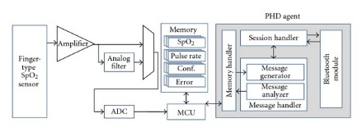

Fig. 2: Architecture of Pulse Oxymeter

1. **Measurement Principle**: The device uses light-emitting diodes (LEDs) to emit red and infrared light through a part of the body, usually a fingertip or earlobe. A photodetector on the opposite side measures the amount of light that passes through the tissue.
2. **Oxygen Saturation (SpO2)**: Oxygenated hemoglobin absorbs more infrared light and allows more red light to pass through, while deoxygenated hemoglobin absorbs more red light and allows more infrared light to pass through. The device calculates the ratio of these two types of light to estimate the oxygen saturation level.
3. **Pulse Rate**: The device also detects the pulsatile nature of blood flow caused by the heartbeat and calculates the pulse rate.
4. **Usage**: To use a pulse oximeter, you simply clip it onto a fingertip (or another suitable body part) and turn it on. It provides a reading within seconds.
5. **Applications**: Pulse oximeters are commonly used in medical settings, such as hospitals and clinics, as well as at home by individuals with respiratory or cardiovascular conditions to monitor their oxygen levels and heart rate. They have become particularly important during the COVID-19 pandemic for monitoring oxygen levels in patients.

application-Specific Integrated Circuits (ASICs) are used in pulse oximeters to integrate various functions into a single chip, improving efficiency, reducing power consumption, and minimizing the size of the device. Here’s an overview of the role and typical features of an ASIC in a pulse oximeter:

**Role of ASIC in Pulse Oximeters**

1. **Signal Processing**: An ASIC handles the processing of signals from the photodetector, including amplification, filtering, and analog-to-digital conversion (ADC).
2. **Data Calculation**: It performs the calculations required to determine oxygen saturation (SpO2) and pulse rate from the digitized signals.
3. **Power Management**: ASICs often include power management features to optimize battery life and ensure stable operation.
4. **Interface Control**: Manages the interface with the display and user controls, as well as any communication interfaces (e.g., Bluetooth, USB).

**Typical Features of Pulse Oximeter ASICs**

1. **Integrated Photodetector Interface**: Direct connection to the photodetector, often including built-in amplifiers and ADCs.
2. **Low Noise and High Accuracy**: Designed to minimize noise and enhance the accuracy of measurements.
3. **Low Power Consumption**: Essential for portable and battery-operated devices.
4. **Digital Signal Processing (DSP)**: Includes specialized DSP algorithms for calculating SpO2 and pulse rate.
5. **Calibration and Compensation**: Built-in functions for calibration and compensation to maintain accuracy over varying conditions.
6. **Communication Interfaces**: Support for interfaces such as I2C, SPI, UART, or even wireless communication for data transfer.
7. **Miniaturization**: Combines multiple functions into a single chip, reducing the overall size of the pulse oximeter.